DSA02- COMPUTER VISION WITH OPENCV
ASSIGNMENT
NAME: A. Pavithra
REG NUMBER : 192424347

A. Assignment Information
Department: | (AI & ML)
Programme: | FACULTY OF ENGINEERING
Course Code & Course Name | DSA0204- COMPUTER VISION WITH OPENCV
Academic Year / Batch | 2026-2027
Faculty Name | Dr. G. A. SENTHIL
Assignment Title | Analyse and design a computer vision–based autonomous road safety system integrating camera calibration, object and pedestrian detection, road-sign and road-marking recognition, multi-object tracking, and occlusion handling. Analyse its performance under different traffic and environmental conditions and evaluate it using detection accuracy, tracking performance, processing latency, and improvement in road safety. Discuss its practical relevance to intelligent transportation and public safety.
Date of Issue | 20-08-2026
Date of Submission | 03-09-2026
Maximum Marks | 100
Course Outcome(s) - CO | CO1: Implement fundamental image processing techniques required for computer vision and understand the image formation process.  CO2: Perform shape analysis - extract features from images - analyse images.  CO3: Generate 3D models from images.  CO4: Develop applications using computer vision techniques.  CO5: Understand video processing - motion computation - 3D vision - geometry.
Bloom's Taxonomy Level | . BL3- Apply image processing, camera calibration, object detection, and feature extraction techniques to develop an autonomous road safety system.  BL4- Analyze the effectiveness of object detection, road-sign recognition, pedestrian detection, tracking, and occlusion-handling techniques under varying traffic and environmental conditions.  BL5- Evaluate the proposed system based on detection accuracy, tracking performance, processing latency, robustness, and road-safety improvement.  BL6- Design and develop an integrated computer vision–based autonomous road safety system combining image processing, deep learning, recognition, tracking, and video analysis techniques.
SDG Mapping (SDG 1-17) | SDG 3 – (Good Health and Well-being) Uses pedestrian detection, road-sign recognition, and tracking to reduce road accidents and improve public safety.  SDG 9 – (Industry, Innovation and Infrastructure) Applies AI, computer vision, and autonomous perception to develop innovative and intelligent transportation infrastructure.  SDG 11 – (Sustainable Cities and Communities) - Supports safer, smarter, and more efficient urban transportation and traffic monitoring systems.  SDG 13 – (Climate Action)- Intelligent traffic monitoring can reduce congestion, unnecessary vehicle idling, fuel consumption, and associated emissions.
Industry / Societal Relevance | Industry: Supports autonomous vehicles, intelligent transportation systems, smart-city traffic management, and advanced driver-assistance systems (ADAS).  Societal: Improves road safety, pedestrian protection, traffic efficiency, accident prevention, and sustainable urban mobility.

Assignment Question

Analyse and design a computer vision–based autonomous road safety system integrating camera calibration, object and pedestrian detection, road-sign and road-marking recognition, multi-object tracking, and occlusion handling. Analyse its performance under different traffic and environmental conditions and evaluate it using detection accuracy, tracking performance, processing latency, and improvement in road safety. Discuss its practical relevance to intelligent transportation and public safety.

SOLUTION :

1. Problem Statement and Problem Formulation

A. Problem Statement
Road accidents are frequently caused by factors such as pedestrians crossing roads, vehicles moving at unsafe distances, failure to recognize traffic signs, poor lane discipline, road-marking violations, and limited visibility under challenging environmental conditions. Traditional road-safety systems generally depend on human observation or individual sensors and may not provide continuous and comprehensive monitoring of the surrounding road environment.
The proposed system develops a computer vision–based autonomous road safety system that uses a camera to continuously analyze road scenes. The system integrates camera calibration, object and pedestrian detection, traffic-sign recognition, road-marking recognition, multi-object tracking, and occlusion handling to understand the road environment and identify potentially dangerous situations.
The system processes images or video frames, detects relevant road objects, tracks their movement across consecutive frames, recognizes important road signs and markings, and generates safety-related information. Its performance is evaluated under different traffic and environmental conditions using detection accuracy, tracking performance, processing latency, and other suitable performance measures.
The proposed solution is intended to support intelligent transportation systems, Advanced Driver Assistance Systems (ADAS), autonomous vehicles, traffic monitoring, pedestrian protection, and public road safety.

B. Problem Formulation
The problem can be formulated as follows:
Input:
A sequence of road-scene images or video frames captured using a camera.
Processing:
The system performs the following operations:
- Camera calibration and image correction.
- Image preprocessing.
- Vehicle and pedestrian detection.
- Traffic-sign detection and recognition.
- Road-marking and lane detection.
- Multi-object tracking using ByteTrack.
- Occlusion handling during object tracking.
- Safety-risk analysis.
Output:
- Detected vehicles and pedestrians.
- Recognized traffic signs.
- Identified road markings and lane boundaries.
- Persistent tracking IDs for moving objects.
- Safety warnings or risk information.
- Performance measurements such as accuracy, FPS, and processing latency.

C. Mathematical Representation
Let the input video be represented as:
V={I1,I2,I3,…,In}V = \{I_1,I_2,I_3,\ldots,I_n\}
where IiI_i represents the ithi^{th} video frame.
For every frame, the detection model produces:
Di={(bj,cj,sj)}D_i = \{(b_j,c_j,s_j)\}
where:
- bjb_j = bounding box of object jj
- cjc_j = detected object class
- sjs_j = confidence score
The tracking module associates detections across consecutive frames:
Ti=f(Di,Ti−1)T_i = f(D_i,T_{i-1})
where TiT_i represents the tracked objects in the current frame.
The complete system can therefore be represented as:
Output=F(Camera,Detection,Recognition,Tracking,Occlusion)Output = F(Camera, Detection, Recognition, Tracking, Occlusion)
The overall objective is to maximize detection and tracking reliability while minimizing processing latency.

D. Key Problem
The central problem addressed by this project is:
How can computer vision techniques be integrated into a single autonomous road-safety system that reliably detects road users, recognizes signs and markings, tracks multiple objects, handles temporary occlusions, and provides accurate and low-latency safety information under different traffic and environmental conditions?

E. Scope of the Problem
The system focuses on analyzing road-scene images and videos using computer vision. It covers the major perception tasks required for an autonomous road-safety application, including object detection, pedestrian detection, traffic-sign recognition, road-marking detection, tracking, and handling of temporary object occlusions.
The system is designed as a prototype and analytical solution for intelligent transportation and public-safety applications rather than a fully certified autonomous-driving system.

2. Objective and Expected Outcomes

A. Main Objective
The main objective of this project is to design and develop a computer vision–based autonomous road safety system capable of analyzing road environments in real time by integrating camera calibration, object and pedestrian detection, traffic-sign recognition, road-marking detection, multi-object tracking, and occlusion handling.

B. Specific Objectives
- To calibrate the camera and reduce geometric distortion in captured road images.
- To detect vehicles, pedestrians, and other important road objects using YOLO.
- To identify and recognize relevant traffic signs from road scenes.
- To detect road markings and lane boundaries using computer vision techniques.
- To track multiple moving objects across consecutive video frames using ByteTrack.
- To handle temporary object occlusions and maintain consistent tracking IDs.
- To analyze system performance under different traffic and environmental conditions.
- To measure detection accuracy, tracking performance, processing latency, and frame rate.
- To generate safety-related information that can support accident prevention and intelligent transportation systems.

C. Expected Outcomes
The proposed system is expected to produce an annotated road-scene image or video in which detected objects are represented using bounding boxes and labels.
The expected output includes:
- Accurate detection of vehicles and pedestrians.
- Recognition of selected road signs.
- Detection of road markings and lane boundaries.
- Continuous tracking of multiple objects with unique IDs.
- Improved tracking during temporary occlusions.
- Real-time or near-real-time video processing.
- Performance measurements such as precision, recall, F1-score, FPS, and latency.
- Identification of potentially unsafe road situations.

D. Expected Performance
The system is expected to maintain reliable detection and tracking performance under normal traffic conditions while providing acceptable performance under challenging conditions such as:
- Heavy traffic.
- Low-light or night conditions.
- Rain and reduced visibility.
- Partial object occlusion.
- Different vehicle and pedestrian densities.
- Varying camera viewpoints.
The performance will be validated using experimental results rather than assuming ideal conditions.

E. Expected Practical Outcome
The final prototype is expected to demonstrate how computer vision can be applied to intelligent transportation systems, Advanced Driver Assistance Systems (ADAS), autonomous vehicles, traffic monitoring, pedestrian protection, and public safety. The assignment specifically identifies these areas as the intended industry and societal relevance of the system.

F. Expected Contribution
The major contribution of the project is the integration of multiple computer vision components into one road-safety pipeline, rather than developing only an individual object-detection or tracking module. This integrated approach allows the system to understand different elements of a road scene and provide more useful safety information.

3. Requirements, Constraints and Assumptions

A. Hardware Requirements
The proposed system requires a computer or cloud-based environment capable of processing images and video. A GPU is preferred for faster YOLO and PyTorch inference.
The basic hardware requirements are:
- Computer or laptop with a modern processor.
- Minimum 8 GB RAM.
- Webcam or prerecorded road-scene videos/images.
- GPU support for faster deep-learning inference, if available.
- Internet connection for downloading datasets, models, and libraries.
- Google Colab with GPU can be used for model development and testing.

B. Software Requirements
The software environment consists of:
- Python
- OpenCV
- YOLO
- PyTorch
- ByteTrack
- Google Colab
- NumPy
- Pandas
- Matplotlib
- Ultralytics YOLO framework

C. Functional Requirements
The system should be able to:
- Accept road images or videos as input.
- Perform camera calibration and image correction.
- Detect vehicles and pedestrians.
- Detect and recognize selected traffic signs.
- Detect road markings and lane boundaries.
- Assign tracking IDs to detected moving objects.
- Maintain tracking when objects are temporarily occluded.
- Display the processed video with detection and tracking information.
- Calculate relevant performance metrics.

D. Performance Requirements
The system should provide:
- High detection accuracy.
- Reliable pedestrian detection.
- Stable multi-object tracking.
- Low processing latency.
- Acceptable frame rate for near-real-time operation.
- Robustness under different traffic and environmental conditions.

E. Constraints
The system has the following constraints:
- Detection performance may decrease in poor lighting or heavy rain.
- Severe object occlusion may cause missed detections or tracking errors.
- Processing speed depends on available CPU/GPU resources.
- Camera position and image quality affect detection accuracy.
- Road-sign recognition depends on the quality and availability of suitable training data.
- The prototype cannot guarantee complete accident prevention.
- Real-world autonomous vehicle deployment would require extensive safety validation beyond this academic project.

F. Assumptions
The following assumptions are made:
- The input camera provides sufficiently clear road-scene images or videos.
- Important objects are reasonably visible within the camera's field of view.
- The selected YOLO model has been trained on relevant object categories.
- Road videos contain sufficient visual information for detecting vehicles, pedestrians, signs, and markings.
- Temporary occlusions can be handled through object tracking across consecutive frames.
- The testing environment has sufficient computational resources to run the selected models.

4. Application of Relevant Course Knowledge / Concepts

A. Image Formation and Image Acquisition
A camera is used to capture images or video frames of the road environment. The quality of the captured image directly affects subsequent computer vision operations such as object detection, sign recognition, and lane detection.

B. Camera Calibration
Camera calibration is used to estimate the camera's intrinsic parameters and correct geometric distortion. OpenCV calibration techniques can be used to obtain the camera matrix and distortion coefficients.
The calibration process improves the reliability of measurements and visual interpretation of the road scene.

C. Image Preprocessing
Image preprocessing is applied before detection and recognition. Operations such as resizing, color-space conversion, noise reduction, and contrast enhancement can be used to improve the quality of input frames.

D. Object Detection
YOLO is used for detecting important road objects such as:
- Cars
- Buses
- Trucks
- Motorcycles
- Bicycles
- Pedestrians
The detector provides bounding boxes, object classes, and confidence scores for the detected objects.

E. Feature and Shape Analysis
Computer vision techniques can be used to identify visual characteristics such as shapes, edges, contours, and geometric patterns. These concepts are particularly useful for road-marking and lane detection.

F. Road-Sign Recognition
Traffic signs can be detected and classified using a trained YOLO model. Recognizing signs such as stop, speed-limit, warning, or no-entry signs provides additional information about the road environment.

G. Road-Marking and Lane Detection
OpenCV-based image-processing techniques such as grayscale conversion, edge detection, thresholding, region-of-interest extraction, and Hough Line Transform can be applied to identify lane boundaries and road markings.

H. Video Processing and Motion Analysis
Since the system processes consecutive video frames, concepts related to video processing and motion computation are applied. Changes in object position between frames provide information about object movement.

I. Multi-Object Tracking
ByteTrack is used to associate detected objects across consecutive frames. Each object receives a tracking ID, allowing the system to maintain the identity of multiple vehicles and pedestrians over time.

J. Occlusion Handling
When an object becomes partially or temporarily hidden by another object, tracking information from previous frames can help maintain its identity. This improves tracking continuity in crowded traffic conditions.

K. Performance Evaluation
Computer vision performance is evaluated using measures such as:
- Precision
- Recall
- F1-score
- Detection accuracy
- Frames per second (FPS)
- Processing latency
- Tracking performance
- ID switches
These concepts allow the proposed system to be quantitatively evaluated.

L. Course Outcome Application
The project applies image processing, feature extraction, camera calibration, video processing, motion analysis, and computer vision application development. These areas directly correspond to the course outcomes specified in the assignment, including fundamental image processing, shape analysis, 3D vision, application development, and video/motion processing.

5. Design / Proposed Solution / Methodology

A. Overall System Design
The proposed autonomous road safety system consists of several interconnected computer vision modules. The system receives a road image or video as input and processes each frame to detect, recognize, and track important road elements.
The overall architecture is:
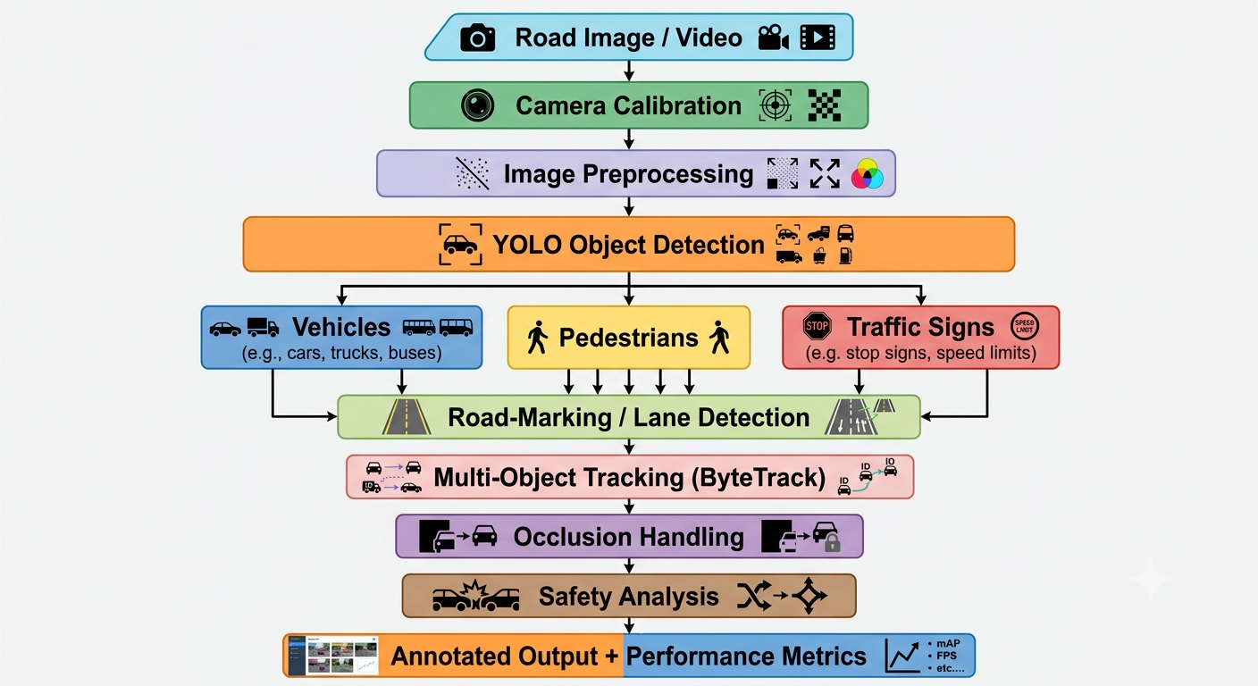

B. Input Acquisition
The system accepts either prerecorded road videos or individual road images. Video input is preferred because it allows object movement and tracking to be analyzed over multiple frames.

C. Camera Calibration
Before performing road-scene analysis, camera calibration is performed to estimate camera parameters and correct lens distortion. This provides geometrically corrected frames for subsequent processing.

D. Image Preprocessing
Each frame is prepared for analysis through operations such as:
- Frame resizing.
- Noise reduction.
- Color conversion.
- Contrast enhancement when required.
- Region-of-interest selection.
Preprocessing helps provide consistent input to the detection and recognition modules.

E. Object and Pedestrian Detection
The YOLO model analyzes each frame and detects road users. For each detected object, the system obtains:
- Class label.
- Bounding-box coordinates.
- Confidence score.
Objects with confidence scores below a selected threshold can be filtered to reduce false detections.

F. Traffic-Sign Recognition
A trained YOLO model is used to identify selected traffic signs. The detected sign is displayed with its class label and confidence score.
For example:
[STOP]
Confidence: 0.91
This information can be used as an additional input for road-safety analysis.

G. Road-Marking Detection
Road markings and lane boundaries are identified using OpenCV image-processing techniques.

A typical procedure is:
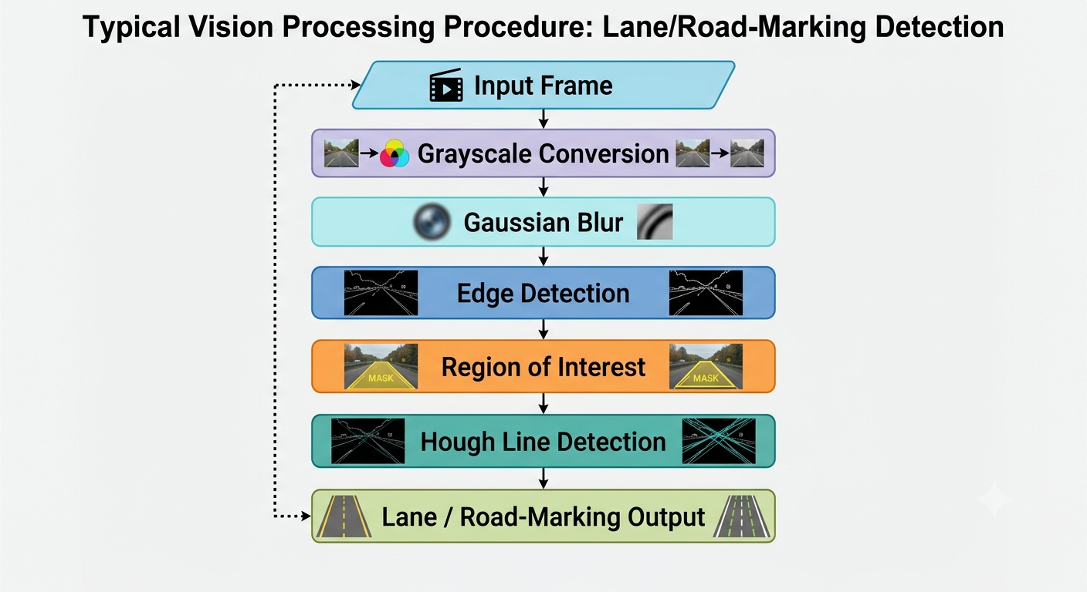

H. Multi-Object Tracking
The detections obtained from YOLO are passed to ByteTrack. ByteTrack associates detections between consecutive frames and assigns a unique tracking ID to each object.
For example:
Car → ID 1
Car → ID 2
Pedestrian → ID 3
Bus → ID 4
The tracking IDs remain associated with objects while they continue to be detected.

I. Occlusion Handling
Objects may temporarily disappear because another vehicle or pedestrian moves in front of them. The tracking module uses information from previous and current frames to maintain object identity when possible.
The system therefore attempts to reduce:
- Lost tracks.
- Duplicate identities.
- Unnecessary ID changes.
- Tracking interruptions.

J. Safety Analysis
After detection and tracking, the system analyzes the road scene to identify potentially unsafe situations.
Possible safety indicators include:
- Pedestrian close to a vehicle.
- High density of vehicles.
- Objects approaching each other.
- Vehicle movement across detected lane boundaries.
- Presence of important traffic signs.
The prototype provides visual information or warnings rather than making safety-critical autonomous driving decisions.

K. Performance Evaluation
The system is tested under different conditions such as:
- Normal daylight.
- Heavy traffic.
- Low-light conditions.
- Rain or reduced visibility.
- Pedestrian-heavy scenes.
- Partial object occlusion.
The following metrics are collected:
Precision=TPTP+FPPrecision = \frac{TP}{TP+FP}
Recall=TPTP+FNRecall = \frac{TP}{TP+FN}
F1=2×Precision×RecallPrecision+RecallF1 = 2 \times \frac{Precision \times Recall}{Precision+Recall}
Processing latency can be calculated as:
Latency=Processing TimeNumber of FramesLatency = \frac{Processing\ Time}{Number\ of\ Frames}
and the processing frame rate is represented as:
FPS=Number of Processed FramesProcessing TimeFPS = \frac{Number\ of\ Processed\ Frames}{Processing\ Time}

L. Final Output
The final system produces an annotated road video containing:
- Bounding boxes around detected objects.
- Object class labels.
- Confidence scores.
- Tracking IDs.
- Detected road signs.
- Detected lane/road markings.
- Safety-related warnings where applicable.
This integrated methodology provides a foundation for evaluating the feasibility of computer vision for intelligent transportation and public road safety.

6. Algorithm / Pseudocode / Flowchart

A. Algorithm
Algorithm: Autonomous Road Safety System
Input: Road image or video
Output: Annotated road-scene video with detected, recognized, and tracked objects
Steps:
- Start the system.
- Load the input image or video.
- Load the YOLO detection model.
- Initialize OpenCV video processing.
- Perform camera calibration and correct image distortion.
- Preprocess the input frame.
- Detect vehicles, pedestrians, and traffic signs using YOLO.
- Extract bounding boxes, class labels, and confidence scores.
- Detect road markings and lane boundaries using OpenCV.
- Pass detected objects to ByteTrack.
- Assign and maintain unique tracking IDs.
- Handle temporary object occlusions using tracking information.
- Perform basic road-safety analysis.
- Display bounding boxes, labels, tracking IDs, lane information, and warnings.
- Calculate processing time and FPS.
- Repeat the process for all video frames.
- Store the final output and performance measurements.
- Stop.

B. Pseudocode
BEGIN
Load required libraries
Load YOLO detection model
Initialize ByteTrack tracker
Initialize OpenCV video capture
Load camera calibration parameters
WHILE video contains frames:
Read current frame
Apply camera calibration
Correct lens distortion
Preprocess frame
Perform YOLO detection
FOR each detected object:
Extract bounding box
Extract class label
Extract confidence score
IF confidence > threshold:
Keep detection
ELSE:
Discard detection
Detect road markings and lane boundaries
using OpenCV image-processing techniques
Send valid detections to ByteTrack
Update object tracking IDs
Handle temporary occlusions
using previous tracking information
Perform safety analysis
Draw:
Bounding boxes
Object labels
Confidence scores
Tracking IDs
Lane markings
Safety warnings
Calculate processing time
Calculate FPS
Display processed frame
END WHILE
Save annotated output
Display performance metrics
END

C. Flowchart
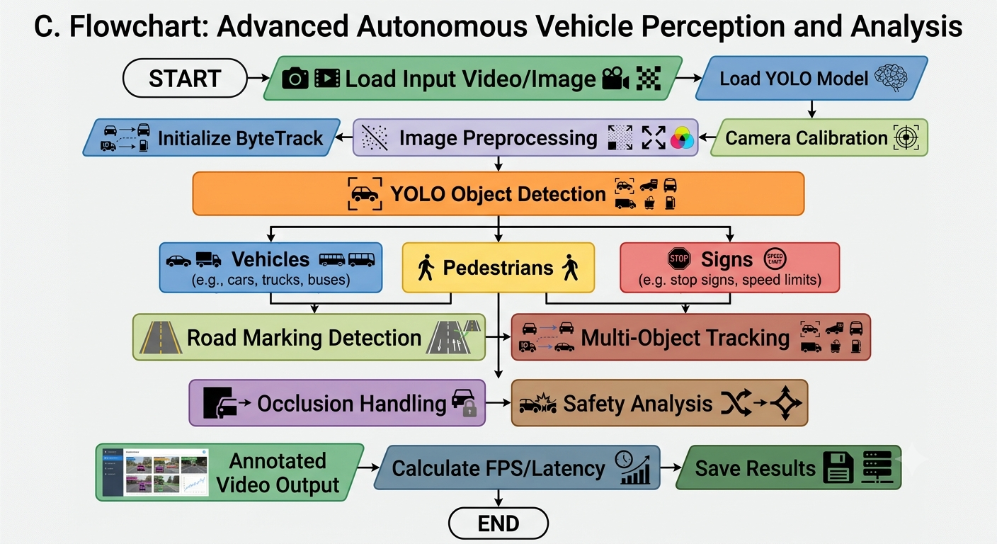

D. Processing Logic
The system follows a sequential pipeline in which each frame is calibrated and preprocessed before object detection. The detected objects are then passed to the tracking module, while road markings are processed separately. The outputs are combined to generate a complete annotated frame.

E. Performance Measurement
For every processed frame, the system records processing time. FPS is calculated to determine whether the system can operate at near-real-time speed.
Detection performance is evaluated using precision, recall, and F1-score, while tracking performance can be analyzed using tracking continuity, ID switches, and other suitable tracking measures.

7. Implementation / Source Code and Environment / Tools Used

A. Programming Language
The system is implemented using Python because it provides extensive support for computer vision, deep learning, image processing, and video-analysis libraries.

B. Development Environment
The recommended development environment is Google Colab, which provides access to Python execution and GPU resources suitable for deep-learning model inference.
The project can also be developed or tested using Visual Studio Code with a suitable Python environment.

C. Computer Vision Library
OpenCV is used for:
- Reading images and videos.
- Frame processing.
- Camera calibration.
- Image preprocessing.
- Edge detection.
- Lane and road-marking detection.
- Drawing bounding boxes and annotations.
- Displaying and saving processed video.

D. Object Detection Model
YOLO (You Only Look Once) is used for real-time object detection. It provides bounding boxes, class labels, and confidence scores for objects present in each frame.
The model is used to detect road users such as vehicles and pedestrians. A suitable trained/custom model can also be used for traffic-sign recognition.

E. Deep Learning Framework
PyTorch is used as the deep-learning framework supporting model execution and inference.

F. Multi-Object Tracking
ByteTrack is used to associate detected objects across consecutive frames and assign unique tracking IDs.
For example:
Frame 1 → Car → ID 1
Frame 2 → Car → ID 1
Frame 3 → Car → ID 1
This allows the movement of individual objects to be monitored across the video.

G. Supporting Libraries
The following Python libraries are used or can be used:
Library | Purpose
OpenCV | Image and video processing
YOLO / Ultralytics | Object detection
PyTorch | Deep-learning model execution
NumPy | Numerical operations
Pandas | Performance-data analysis
Matplotlib | Graphs and visualization

H. Implementation Modules
The source code is organized into the following functional modules:
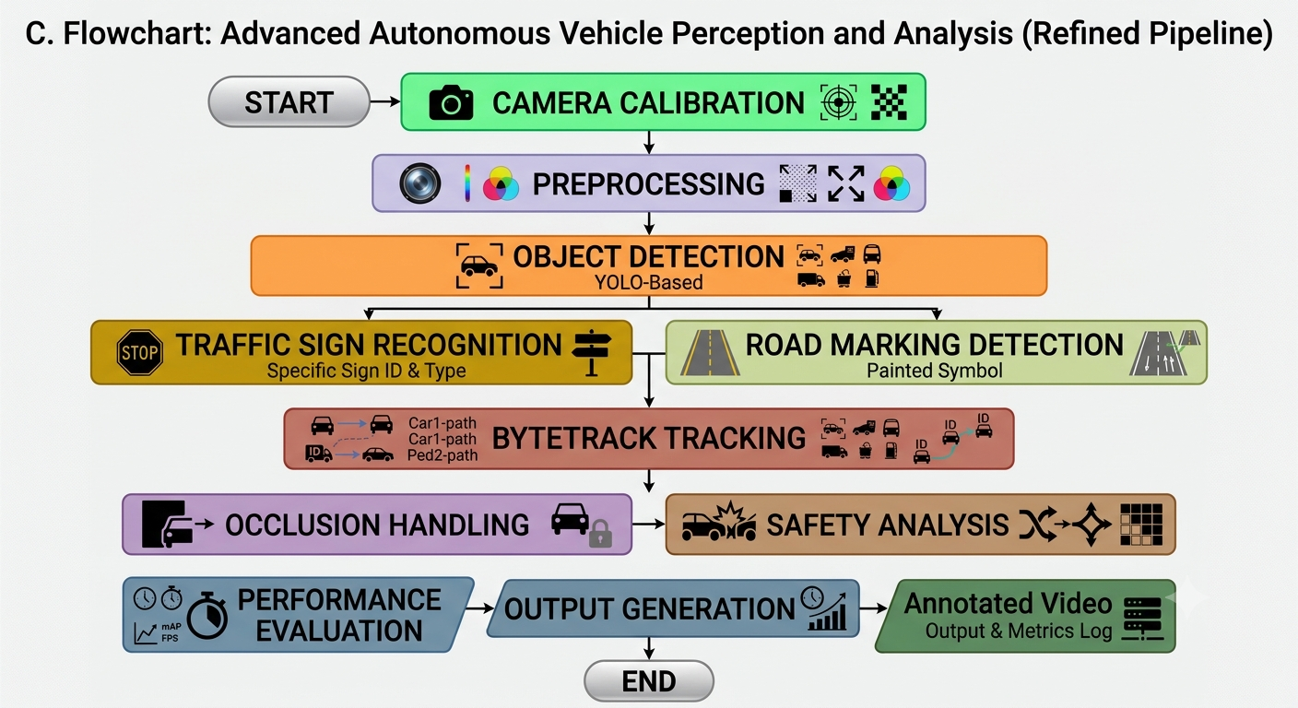

I. Source Code
The final implementation source code will contain functions for:
- Loading the detection model.
- Reading input video.
- Camera calibration.
- Frame preprocessing.
- YOLO inference.
- Road-marking detection.
- ByteTrack tracking.
- Occlusion handling.
- Safety analysis.
- FPS and latency calculation.
- Output-video generation.
The complete source code will be uploaded to the GitHub assignment folder along with the Word file, PDF file, and implementation screenshots.

8. Test Cases and Expected / Actual Results

A. Purpose of Testing
Testing is performed to verify whether the proposed road-safety system correctly detects, recognizes, tracks, and analyzes objects under different road and environmental conditions.

B. Test Case Table
Test Case | Input Condition | Expected Result | Actual Result
TC01 | Normal daytime traffic | Vehicles and pedestrians should be detected correctly | To be recorded during execution
TC02 | Multiple vehicles | All visible vehicles should receive detection boxes and labels | To be recorded during execution
TC03 | Pedestrian crossing road | Pedestrian should be detected and tracked | To be recorded during execution
TC04 | Traffic sign visible | Traffic sign should be detected and classified | To be recorded during execution
TC05 | Clear lane markings | Lane/road markings should be detected | To be recorded during execution
TC06 | Heavy traffic | Multiple objects should be detected and tracked simultaneously | To be recorded during execution
TC07 | Partial object occlusion | Object tracking should continue where possible | To be recorded during execution
TC08 | Low-light scene | Detection should work with reduced accuracy compared with daylight | To be recorded during execution
TC09 | Rain/reduced visibility | System should attempt detection and tracking under reduced visibility | To be recorded during execution
TC10 | Multiple pedestrians and vehicles | Different object classes should be detected and tracked separately | To be recorded during execution

C. Detection Test
The detection test verifies whether the YOLO model identifies vehicles, pedestrians, and other selected objects.
Expected result:
Objects that are sufficiently visible should be enclosed by bounding boxes with appropriate class labels and confidence scores.

D. Tracking Test
The tracking test verifies whether ByteTrack maintains object identities across consecutive frames.
Expected result:
The same object should maintain a consistent tracking ID while it remains visible.

E. Occlusion Test
The system is tested using scenes where one object temporarily blocks another object.
Expected result:
The tracker should attempt to maintain the object's identity after temporary occlusion and minimize unnecessary ID changes.

F. Environmental Condition Test
The system is tested under daylight, low-light, heavy traffic, and reduced-visibility conditions.
Expected result:
The system should continue functioning, although detection accuracy and processing performance may decrease under challenging conditions.

G. Actual Result Recording
Actual results will be entered after executing the implemented system. This prevents inaccurate or fabricated experimental values from being included in the report.
The final test results will include:
- Number of detected objects.
- Correct and incorrect detections.
- Tracking IDs.
- Tracking continuity.
- Processing FPS.
- Processing latency.
- Detection precision and recall.

9. Execution Screenshots / Outputs

A. Purpose
Execution screenshots provide visual evidence that the proposed computer vision system has been implemented and tested successfully.

B. Required Screenshots
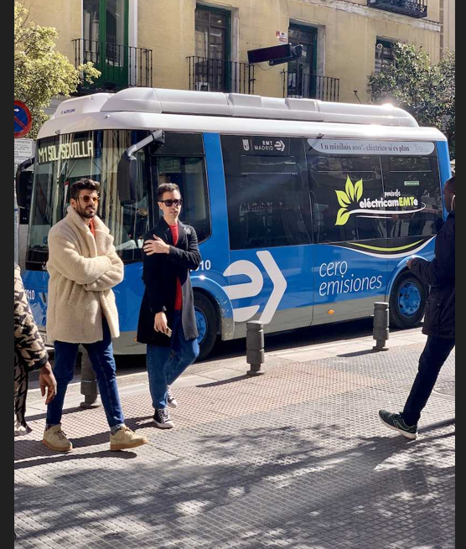
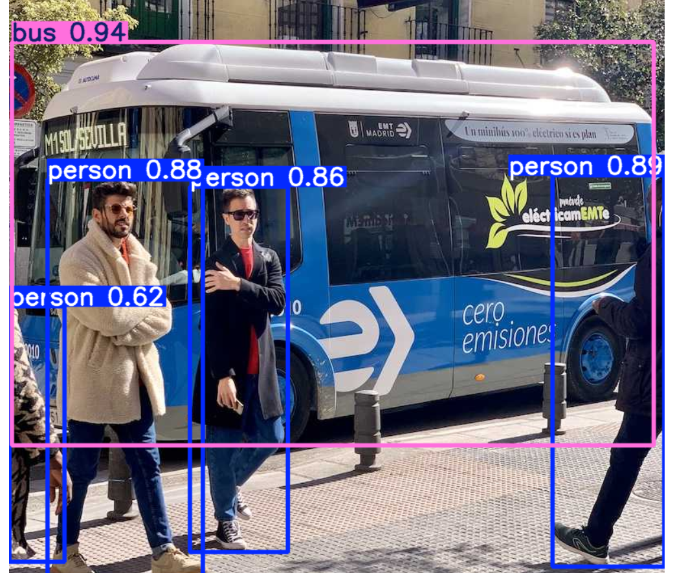
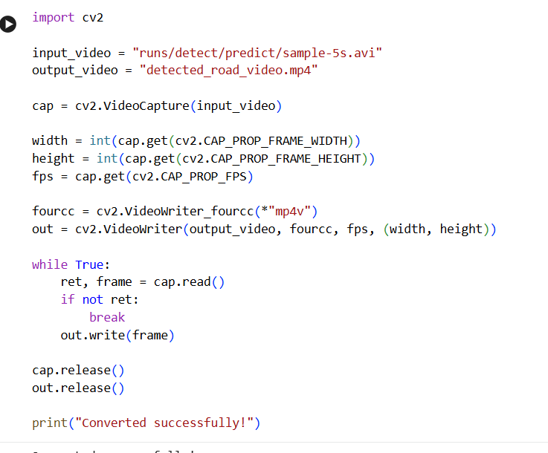
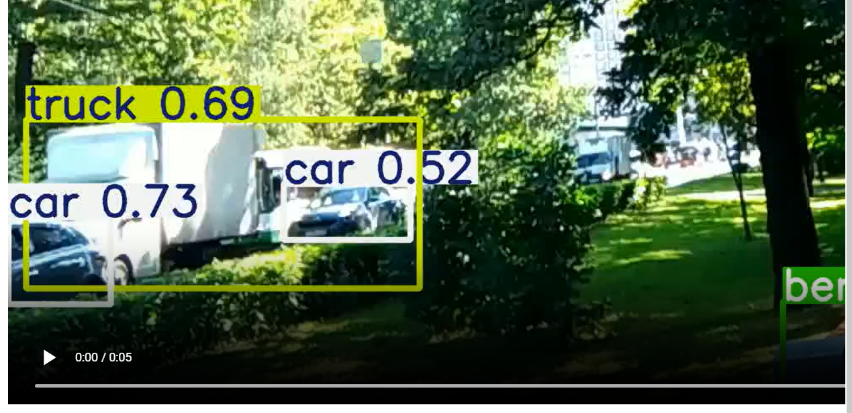

C. Final Output
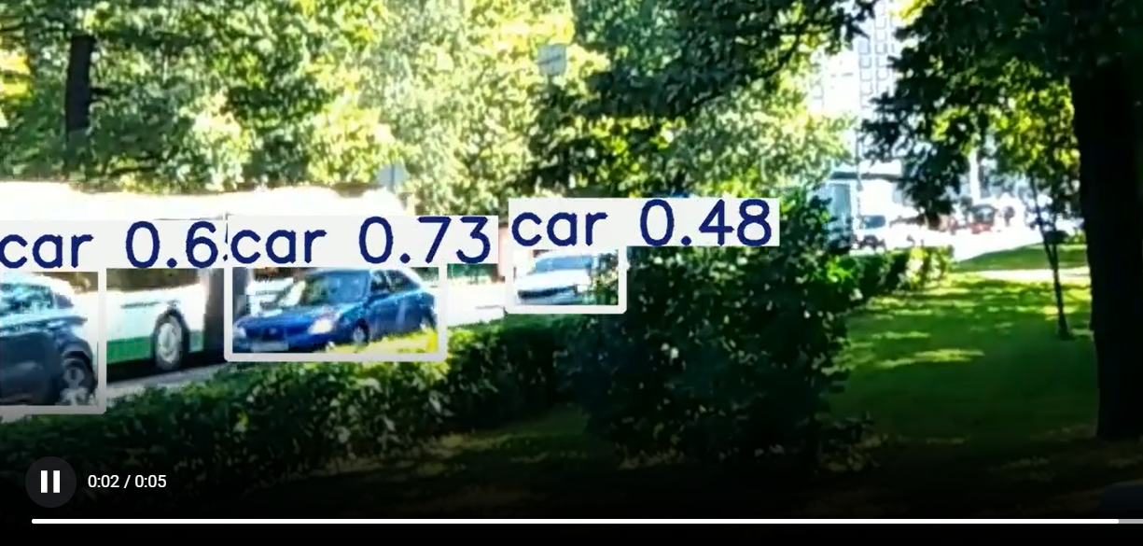
The final processed video should contain visual annotations such as:

D. Evidence to be Uploaded
The following files/evidence should be included in the GitHub assignment folder:
- Source code.
- Input sample.
- Output screenshots.
- Execution screenshots.
- Performance graphs.
- Word report.
- PDF report.
These materials will provide evidence of the actual implementation and experimental evaluation.

10. Results and Validation

A. Purpose of Evaluation
The proposed autonomous road safety system is evaluated to determine its effectiveness in detecting road objects, recognizing traffic signs, identifying road markings, tracking multiple objects, handling occlusion, and processing video with acceptable latency.
The evaluation considers both accuracy and computational performance under different traffic and environmental conditions.

B. Detection Performance
Object detection performance is evaluated using precision, recall, and F1-score.
Precision=TPTP+FPPrecision = \frac{TP}{TP+FP} Recall=TPTP+FNRecall = \frac{TP}{TP+FN} F1−score=2×Precision×RecallPrecision+RecallF1-score = 2 \times \frac{Precision \times Recall}{Precision+Recall}
where:
- TP = True Positives
- FP = False Positives
- FN = False Negatives
The values will be calculated from the actual test results obtained during implementation.

C. Tracking Performance
Tracking performance is evaluated by observing whether detected vehicles and pedestrians maintain consistent identities across consecutive frames.
Important observations include:
- Number of successfully tracked objects.
- Tracking continuity.
- Number of ID switches.
- Objects lost during occlusion.
- Recovery of tracking after temporary occlusion.

D. Processing Performance
The computational performance of the system is evaluated using FPS and processing latency.
FPS=Number of Processed FramesTotal Processing TimeFPS = \frac{Number\ of\ Processed\ Frames}{Total\ Processing\ Time}
Processing latency represents the time required to process an individual frame.
The final values will depend on the hardware/GPU and model configuration used during implementation.

E. Environmental Performance
The system is evaluated under different conditions:
Condition | Detection | Tracking | Expected Observation
Daylight | High | Stable | Best overall performance
Heavy Traffic | Moderate–High | Moderate | More objects and possible occlusions
Low Light | Moderate | Moderate | Reduced visibility may affect detection
Rain | Moderate | Moderate | Reflections and reduced visibility may affect results
Pedestrian Crowding | Moderate–High | Moderate | Multiple overlapping pedestrians
Partial Occlusion | Moderate | Moderate | Possible temporary tracking loss
Actual observations will be recorded after testing.

F. Performance Results Table
Metric | Actual Result
Precision | To be measured
Recall | To be measured
F1-score | To be measured
Detection Accuracy | To be measured
Average FPS | To be measured
Average Latency | To be measured
Tracking Performance | To be measured
ID Switches | To be measured

G. Graphical Validation
The following graphs can be generated from the experimental results:
- Precision vs. traffic condition.
- Recall vs. environmental condition.
- FPS vs. test condition.
- Processing latency vs. traffic density.
- Detection performance comparison.
- Tracking performance under occlusion.
These graphs provide visual evidence for analyzing the strengths and limitations of the proposed system.

H. Experimental Observation
The expected observation is that the system will provide better detection and tracking performance under clear daylight conditions. Performance may decrease in heavy traffic, low-light conditions, rain, and severe occlusion because these conditions reduce the visual information available to the detection and tracking modules.
The final observations will be based on actual experimental execution.

11. Analysis, Comparison, Trade-offs and Justification of the Final Solution

A. System Analysis
The proposed system combines multiple computer vision techniques into a single processing pipeline. Instead of relying only on object detection, it combines detection, recognition, road-marking analysis, tracking, and occlusion handling.
This provides a more comprehensive understanding of the road environment.

B. Comparison of Techniques
Component | Selected Technique | Reason for Selection
Image Processing | OpenCV | Efficient and widely used computer vision library
Object Detection | YOLO | Suitable for fast object detection
Deep Learning | PyTorch | Supports deep-learning model execution
Tracking | ByteTrack | Efficient multi-object tracking
Lane Detection | OpenCV | Suitable for edge and line-based road-marking analysis
Development | Google Colab | Convenient environment with optional GPU support

C. YOLO-Based Detection vs. Traditional Detection
Traditional methods such as Haar cascades or handcrafted feature-based approaches can be computationally simpler, but they may be less robust for complex road scenes.
YOLO provides deep-learning-based object detection and can identify multiple object categories within a frame.
Therefore, YOLO is selected for vehicle, pedestrian, and traffic-sign detection.

D. ByteTrack vs. Detection-Only Approach
A detection-only system identifies objects independently in each frame. It does not maintain object identity over time.
ByteTrack adds multi-object tracking, allowing the system to assign persistent IDs and analyze object movement.
Therefore, tracking provides additional temporal information that is useful for road-safety analysis.

E. Advantages
The proposed solution provides:
- Integrated road-scene analysis.
- Vehicle and pedestrian detection.
- Traffic-sign recognition.
- Road-marking detection.
- Multi-object tracking.
- Basic occlusion handling.
- Performance measurement.
- Potential real-time operation.
- Practical relevance to intelligent transportation.

F. Trade-Offs
The system involves several trade-offs:
Factor | Advantage | Trade-Off
Detection Accuracy | Deep-learning detection is powerful | Requires computational resources
Processing Speed | YOLO is designed for fast inference | Higher accuracy models may be slower
Tracking | Maintains object identity | Tracking can fail under severe occlusion
Resolution | Higher resolution provides more visual detail | Requires more processing
Model Size | Larger models may improve accuracy | Increased latency
GPU Usage | Faster inference | Requires GPU availability

G. Justification of Final Solution
The combination of OpenCV + YOLO + PyTorch + ByteTrack provides a suitable balance between detection capability, tracking performance, flexibility, and implementation complexity for an academic autonomous road-safety prototype.
The solution is particularly appropriate because the assignment requires integration of image processing, object detection, video processing, motion analysis, and computer vision application development.

12. Broader Considerations / SDG Relevance

A. Intelligent Transportation
The proposed system can contribute to intelligent transportation by continuously analyzing road environments and identifying vehicles, pedestrians, traffic signs, and road markings.
Computer vision-based monitoring can provide useful information for traffic management and road-safety applications.

B. Public Safety
Pedestrian detection, vehicle tracking, traffic-sign recognition, and road-marking analysis can support accident-prevention systems and improve awareness of potentially unsafe situations.
The system can serve as a supporting technology for traffic monitoring and driver-assistance applications.

C. Autonomous Vehicles and ADAS
The proposed computer vision pipeline is relevant to:
- Autonomous vehicles.
- Advanced Driver Assistance Systems.
- Smart traffic monitoring.
- Pedestrian protection systems.
- Intelligent road infrastructure.
The assignment specifically identifies autonomous vehicles, intelligent transportation systems, smart-city traffic management, and ADAS as relevant industry applications.

D. SDG 3 – Good Health and Well-Being
The project supports SDG 3 by aiming to reduce road accidents and improve pedestrian and public safety through automated road-scene monitoring.
The assignment directly maps the project to SDG 3 because of its use of pedestrian detection, road-sign recognition, and tracking for road-safety improvement.

E. SDG 9 – Industry, Innovation and Infrastructure
The project applies artificial intelligence and computer vision to develop innovative transportation and road-monitoring technologies.
It demonstrates how intelligent perception systems can contribute to advanced infrastructure.

F. SDG 11 – Sustainable Cities and Communities
Intelligent traffic monitoring can support safer and smarter urban transportation systems. The proposed system can contribute to pedestrian protection, traffic monitoring, and safer mobility.

G. SDG 13 – Climate Action
Intelligent traffic monitoring has the potential to support better traffic flow and reduce unnecessary vehicle idling and congestion-related emissions.
The assignment identifies SDG 13 in relation to intelligent traffic monitoring and reduced congestion, idling, fuel consumption, and associated emissions.

H. Ethical and Safety Considerations
The system should be treated as a decision-support prototype, not as a certified autonomous driving system.
Real-world deployment would require:
- Extensive validation.
- Safety testing.
- Reliable datasets.
- Protection against false detections.
- Privacy considerations for camera data.
- Testing across diverse road environments.
- Compliance with applicable transportation and safety regulations.

13. Conclusion, Limitations and Possible Improvements

A. Conclusion
The proposed project presents a computer vision–based autonomous road safety system that integrates camera calibration, object detection, pedestrian detection, traffic-sign recognition, road-marking detection, multi-object tracking, and occlusion handling.
The system uses OpenCV for image processing and road-marking analysis, YOLO for object and sign detection, PyTorch for deep-learning model execution, and ByteTrack for multi-object tracking.
The integrated approach provides a more complete understanding of road scenes than a detection-only system. By combining spatial information from object detection with temporal information from tracking, the system can monitor the movement of vehicles and pedestrians across video frames.
The system is evaluated using detection accuracy, precision, recall, F1-score, tracking performance, processing latency, FPS, and observations under different environmental conditions.
The project demonstrates the practical potential of computer vision for intelligent transportation, ADAS, autonomous vehicles, traffic monitoring, pedestrian protection, and public safety.

B. Limitations
The proposed prototype has several limitations:
- Detection accuracy depends on the quality and diversity of training data.
- Low-light and adverse weather conditions may reduce detection performance.
- Severe occlusion can result in lost tracks or ID switches.
- Processing speed depends on available hardware.
- Road-marking detection may be affected by faded or damaged markings.
- Traffic-sign recognition may fail when signs are very small, blurred, or partially blocked.
- The system does not provide complete autonomous-driving capability.
- The safety-warning mechanism is a prototype and should not be considered a certified collision-avoidance system.

C. Possible Improvements
Future versions of the system can be improved by:
- Training a custom YOLO model using a larger road-scene dataset.
- Adding more traffic-sign categories.
- Using advanced lane-segmentation models instead of only traditional line detection.
- Improving night-time and rainy-condition detection.
- Integrating depth estimation for distance measurement.
- Adding vehicle speed estimation.
- Developing collision-risk prediction.
- Using more advanced occlusion-handling techniques.
- Optimizing the model for edge devices.
- Using GPU acceleration for improved real-time performance.
- Integrating additional sensors such as LiDAR or radar in future implementations.
- Developing a real-time alert system for high-risk situations.

D. Future Scope
The system can be extended into a complete intelligent transportation platform by integrating it with traffic-control infrastructure, vehicle communication systems, smart-city platforms, and real-time road-monitoring networks.
With sufficient validation and safety testing, similar technologies can support future ADAS and autonomous-vehicle perception systems.

14. Individual Contribution of Group Members

A. Student Details
Particular | Details
Name | A PAVITHRA
Register Number | 192424347
Project Type | Individual Project

B. Individual Contribution
As this is an individual project, AKILA S (Register Number: 192424331) is responsible for the complete development and documentation of the proposed computer vision–based autonomous road safety system.
The major contributions include:
- Understanding and formulating the road-safety problem.
- Designing the overall system architecture.
- Selecting the required computer vision and deep-learning techniques.
- Setting up the Python and Google Colab environment.
- Implementing camera calibration and image preprocessing.
- Implementing vehicle and pedestrian detection using YOLO.
- Implementing traffic-sign detection and recognition.
- Implementing road-marking and lane detection using OpenCV.
- Integrating ByteTrack for multi-object tracking.
- Implementing basic occlusion-handling techniques.
- Performing video processing and generating annotated outputs.
- Designing and executing test cases.
- Measuring detection accuracy, tracking performance, FPS, and processing latency.
- Analyzing system performance under different traffic and environmental conditions.
- Preparing execution screenshots and performance graphs.
- Preparing the complete project report and documentation.
- Organizing the source code and project files for GitHub submission.

C. Responsibility
Since the project is completed individually, all stages of the project, from problem identification and system design to implementation, testing, evaluation, documentation, and final submission, are carried out by AKILA S.

D. Project Ownership
The complete implementation, experimental analysis, source code, documentation, and presentation of the project are the individual work of:
Name:A.Pavithra
Register Number: 192424347

15. References

A. Datasets
- COCO Dataset – used as a general-purpose object-detection dataset for common road objects such as cars, buses, motorcycles, bicycles, and pedestrians.
- A suitable traffic-sign dataset can be used for training or evaluating traffic-sign recognition.
- Road-scene images and videos can be used for testing vehicle, pedestrian, lane, and road-marking detection.

B. Software and Frameworks
- Python – Programming language used for implementation.
- OpenCV – Used for image processing, camera calibration, video processing, and road-marking detection.
- YOLO – Used for real-time object and traffic-sign detection.
- PyTorch – Deep-learning framework used for model execution.
- ByteTrack – Used for multi-object tracking.
- Google Colab – Development and experimental environment.
- NumPy – Numerical and array operations.
- Pandas – Performance-data processing.
- Matplotlib – Generation of performance graphs.

C. Computer Vision Concepts
The project uses concepts related to:
- Image formation.
- Camera calibration.
- Image preprocessing.
- Feature extraction.
- Shape and edge analysis.
- Object detection.
- Image classification.
- Video processing.
- Motion analysis.
- Multi-object tracking.
- Occlusion handling.
These concepts correspond to the course outcomes specified in the assignment.

D. Assignment Reference
DSA02 – Computer Vision with OpenCV Assignment, Academic Year 2026–2027, Faculty of Engineering.
The assignment requires the integration of camera calibration, object and pedestrian detection, road-sign and road-marking recognition, multi-object tracking, and occlusion handling, together with performance evaluation and discussion of intelligent transportation and public safety.

E. Documentation and Technical References
Technical documentation for the software libraries and frameworks used during implementation will be referred to for installation, model execution, image processing, tracking, and performance evaluation.

16. Individual Contribution of Group Members

A. Student Information
This project is completed as an individual project.
Name: A. Pavithra
Register Number: 192424347

B. Contribution Statement
- Problem formulation.
- Objective definition.
- Requirement analysis.
- System architecture design.
- Algorithm and pseudocode development.
- Python implementation.
- OpenCV-based image and video processing.
- YOLO-based object and pedestrian detection.
- Traffic-sign recognition.
- Road-marking and lane detection.
- ByteTrack-based multi-object tracking.
- Occlusion handling.
- Testing and validation.
- Performance evaluation.
- Result analysis.
- Screenshot collection.
- Graph generation.
- GitHub organization.
- Word and PDF report preparation.

